**PRACTICAL 4 : Temperature Detector**

**Aim :** To measure and display temperature using a temperature sensor with Arduino.

**Overview :**

This project uses a temperature sensor to measure environmental temperature and display it on a serial monitor or other output devices. It introduces sensor interfacing with Arduino and provides a fundamental understanding of analog-to-digital conversion in IoT applications.

**Materials Required :**

* Arduino Uno R3
* Temperature Sensor (TMP36)
* Pushbutton
* Slide Switch
* Peizo
* Jumper Wires
* Arduino IDE (Installed on your Computer)

**Circuit Connection and Steps :**

1. **Connect the Temperature Sensor (TMP36) :**
   * **VCC** (left pin) → **5V**
   * **GND** (right pin) → **GND**
   * **VOUT** (middle pin) → **Analog Pin A5**
2. **Connect the Buzzer and Pushbutton:**
   * Buzzer: Positive (+) to Digital Pin 11, Negative (-) to GND
   * Pushbutton: One terminal to Digital Pin 6, the other to GND
3. **Set Up the Arduino Environment :**
   * Open Arduino IDE, select the correct board and port & upload the code.

**Circuit Diagram :**

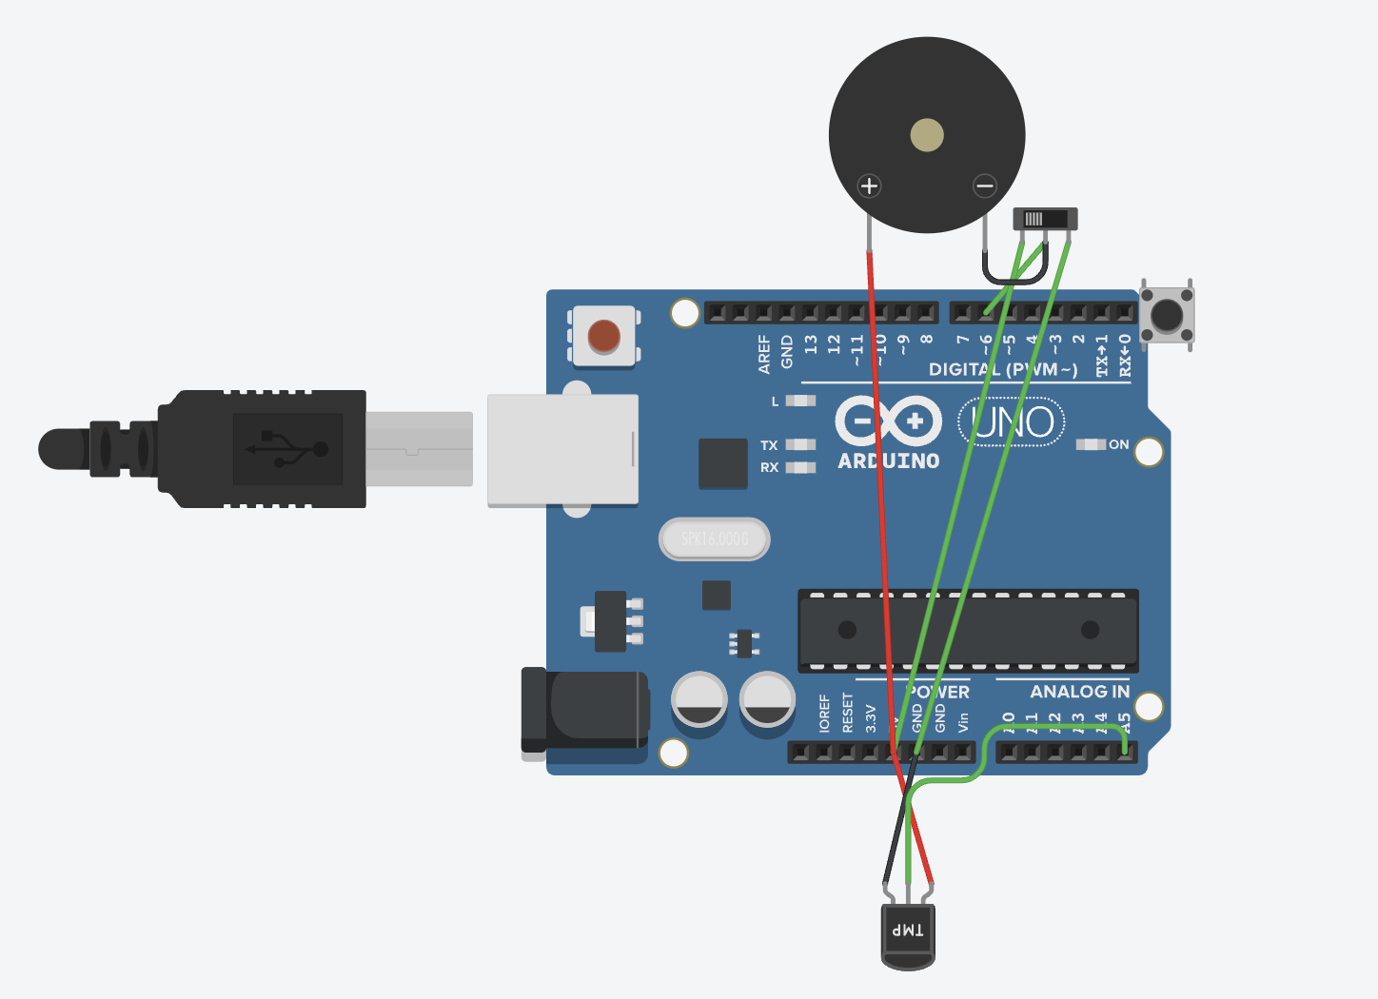

**Schematic Diagram :**

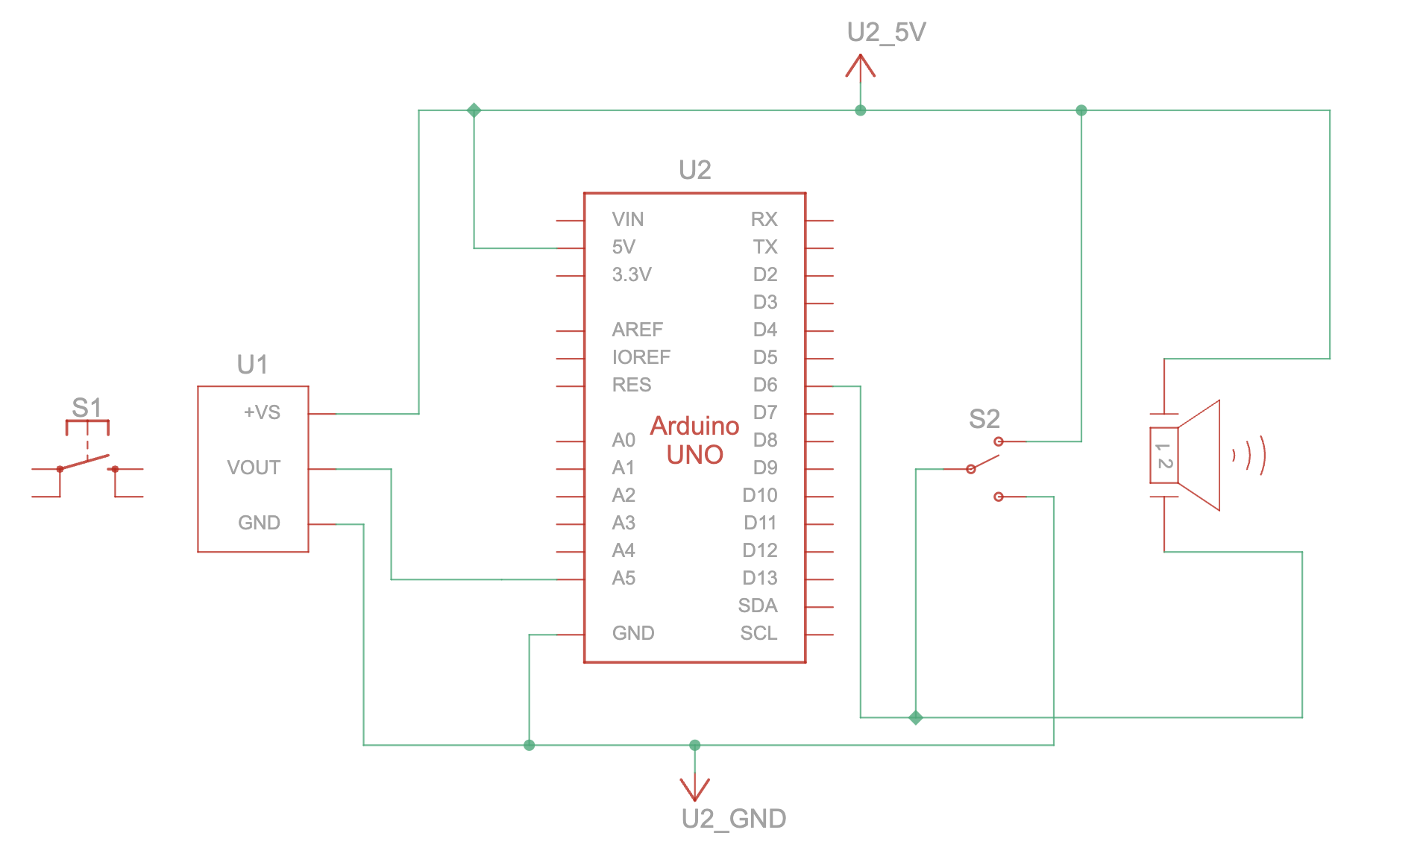

**Code :**

// C++

// Define the pin connections for the components

int tempSensorPin = A5; // Pin connected to the temperature sensor

int buttonPin = 6; // Button to activate temperature reading

int ledPin = LED_BUILTIN; // Built-in LED for indication

int TMP = 0; // Variable for Fahrenheit temperature

int Celcius = 0; // Variable for Celsius temperature

// Setup function runs once when the program starts

void setup() {

pinMode(ledPin, OUTPUT); // Set LED as OUTPUT

pinMode(buttonPin, INPUT); // Set button as INPUT

pinMode(tempSensorPin, INPUT); // Set temperature sensor as INPUT

Serial.begin(9600); // Start serial communication

}

// Loop function runs repeatedly

void loop() {

// Blink LED to show system is running

digitalWrite(ledPin, HIGH);

delay(100); // Wait for 100 milliseconds

digitalWrite(ledPin, LOW);

delay(100); // Wait for 100 milliseconds

// Check if the button is pressed

if (digitalRead(buttonPin) == LOW) {

// Read temperature and convert

TMP = (-40 + 0.878679 * (analogRead(tempSensorPin) - 20)); // Fahrenheit

Celcius = (-40 + 0.488155 * (analogRead(tempSensorPin) - 20)); // Celsius

// Print temperature readings to Serial Monitor

Serial.print("--> Temperature: ");

Serial.print(TMP);

Serial.println("°F");

Serial.print("--> Temperature: ");

Serial.print(Celcius);

Serial.println("°C\n");

}

}

**Results :**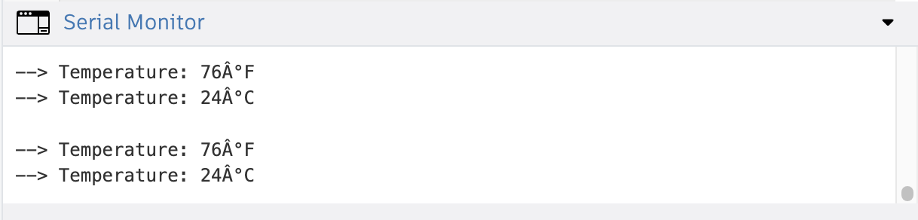

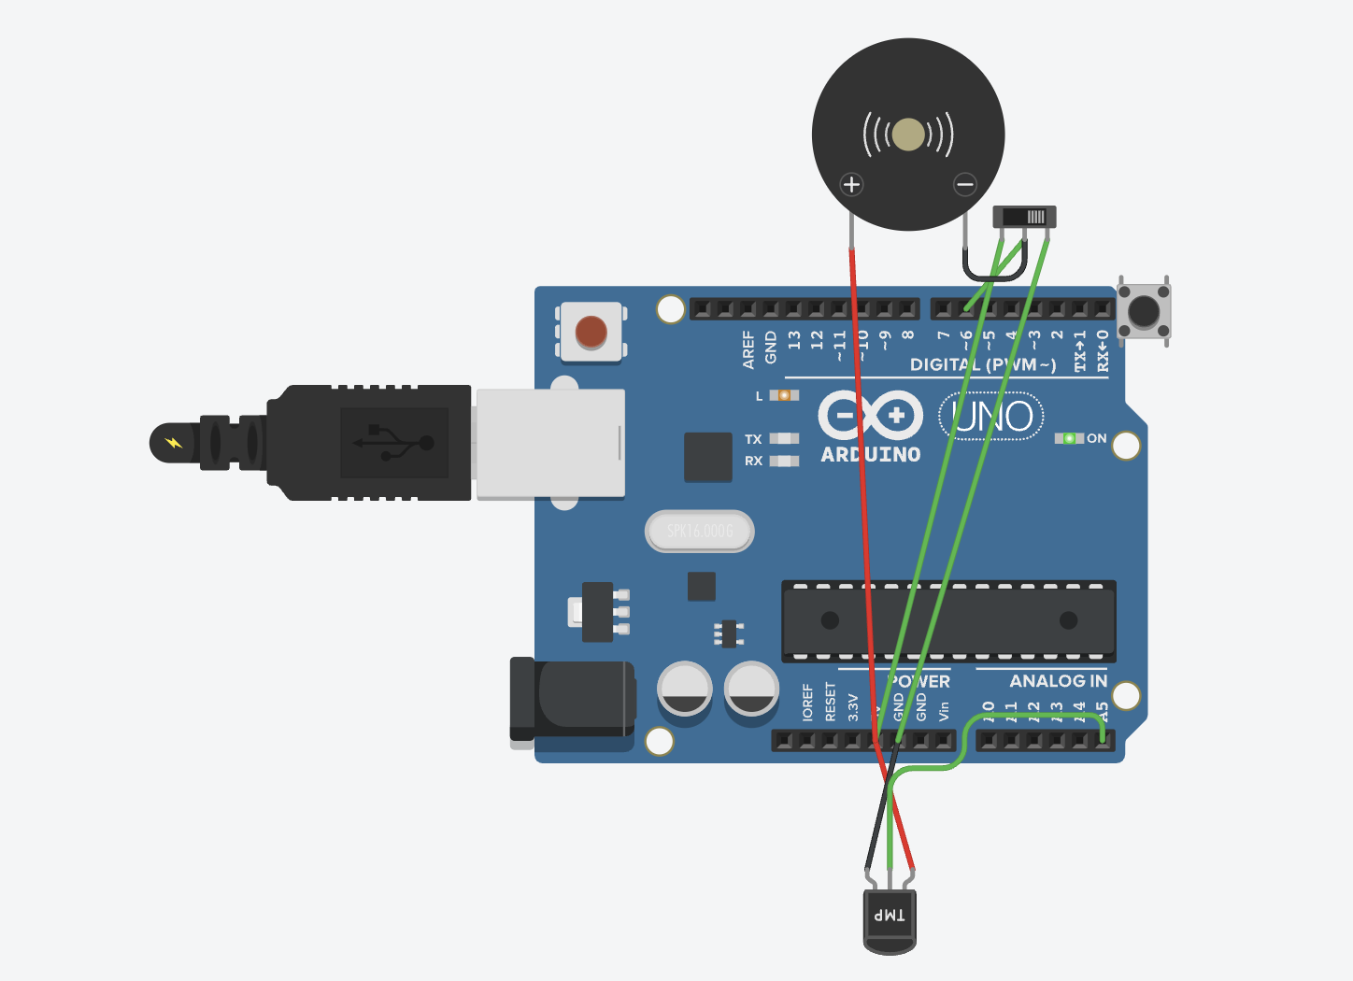

**Conclusion :**

The Temperature Detector project successfully measures and displays temperature readings using a sensor and Arduino. It introduces the fundamental concept of sensor interfacing and data acquisition. This project serves as a foundation for more advanced IoT applications in environmental monitoring and smart home systems.